Information Processing
Working Memory and Emotion
Heather P. Wright Karlson
May 7, 2013
Bentley University
Running head: WORKING MEMORY AND EMOTION

Abstract
This paper examines the human memory system including the limits of working memory. Models of working memory, the capacity of working, as well the relationship between long term memory and working memory are discussed. The emotion of anxiety is also discussed as it relates to working memory.
Keywords: working memory, phonological loop, visuospatial sketchpad, attention, cognitive load, chunking, anxiety
Introduction
In a world saturated with information, we are bombarded with demands for our attention at almost every moment. Despite what we think, most of our environment is not attended to closely until it needs to be. Humans screen out distractors and process information with the help of focused attention. Information processing, vital for cognition, is a multi-faceted interaction that taps into the entire perceptual system. This highly interconnected perceptual system works together efficiently to detect, organize, and process input. The structure and limits of working memory provide insight into the limits of human capability for processing information and can serve to inform interaction designers about designing systems that support human working memory capability.
Science indicates that information processing is largely based on human memory capability. Three distinct types of memory, including sensory, working, and long-term make up the memory system. Memory systems serve a number of important functions including encoding, storing, consolidating, and retrieving information (García-Lázaro, Ramirez-Carmona, Lara-Romero, & Roldan-Valadez, 2012). At one end of the memory continuum is sensory memory; the biological response and pre-attentive processes. On the other end of the continuum, sits long-term memory; the infinite capacity store of knowledge units and their associated networks of long term memory. Along the continuum, working memory is located at the intersection of perception, attention and memory (Baddeley, 1992).
Working Memory
A number of models have been developed in order to explain the working memory system. One of the most well known models, revised and updated multiple times since first published in 1974, is Baddeley’s model of working memory. This model asserts that working memory, “consists of a limited ‘workspace’ which can be divided between storage and control processing demands” (Baddeley & Hitch, 1974, p.76). According to Baddeley, working memory capability is made possible through several components. In his model, the central executive and its respective slave systems, including the visuospacial sketchpad, the phonological loop, and the episodic buffer all play a role. Using this model, the central executive plays at least three important roles in information processing, 1) coordinating the working memory components 2) controlling attention to pick out some streams of incoming information while rejecting others, 3) selecting and manipulating information in long term memory (Baddeley, 1996).
The information processing capability of the central executive center is enabled by separate components that appear to have, at least in part, dedicated functions (Salway & Logie, 1995). Verbal and auditory traces are stored for a brief few seconds in the phonological loop, while spatial and visual traces are stored temporarily in the visuospatial sketchpad (Baddeley, 2000). The verbal and auditory components encode and chunk visual and auditory information for processing. The phonological loop maintains material by subvocal repetition, and registers visuals in the phonological store by subvocalization (Baddeley, 1992). The components of the working memory system are said to, “ require [a] series of retrievals that compete for a unique spotlight of retrieval” (Barrouillet, Bernardin, & Camos, p.85). The visuospatial sketchpad and the phonological loop rely on the central executive for coordination (Baddeley, 1996). Performing tasks simultaneously and switching between tasks frequently will require the oversight from the central executive and will consequently limit working memory functionality (Barrouillet, Bernardin, & Camos, 2004). The central executive is often described as a single coordinated system that controls the slave systems. It remains unclear if this is the case, or if the central executive is, instead, a set of autonomous processes that control the components of working memory by way of an “executive committee” (Baddeley, 1996). Cowan has developed another well known model which describes working memory as being the activated information that is the focus of attention. He proposes that information that is attended to, by focused attention, will be processed with greater depth and combined into new larger units of information (Cowen, 2010 p.452). Whether it is an embedded process, as Cowan suggests, or a system structured by component, as Baddeley suggests, is unresolved.
Working Memory Capacity
Despite disagreement surrounding the structure of working memory, it is clear that auditory and visual information require working memory resources in order to be processed in a short period of time (estimated to be seconds to minutes). The resources of working memory are shared, meaning that attentional systems as well as the processing system compete for the finite resources of working memory (Just & Carpenter, 1992). Depending on the amount of learning required, tasks will make different demands on the capacity of working memory. Cognitive Load Theory defines the demands made on the system as cognitive load. Paas, Renkl, and Sweller (2003) state, “Intrinsic, extraneous, and germane cognitive loads are additive in that, together, the total load cannot exceed the working memory resources available if learning is to occur” (p.2). The demands put on working memory capacity are not limited to cognitive load.
Working Memory Efficiency
The limited capacity of working memory requires efficiency and information is consolidated so that it can be processed efficiently. In order to maximize the amount of information held at one time, information is bundled together into chunks. It appears that anywhere from three or four chunks of information can be held at one time (Cowan, 2001). Chunking occurs through perceptual encoding, which is based on perceptual organizational principles where each perceived distal object occupies one slot. A fixed number of slots exist in working memory for the storage of information and each slot can hold a single chunk of information. (Quinlan & Cohen 2012). While the amount of information contained in a chunk can vary, the number of chunks that can be remembered is fixed (Quinlan & Cohen 2012). The working memory system uses strategies such as cognitive and spatial binding to break information into chunks. For example working memory will break the numbers 7, 6, 5, 3 into four separate chunks reaching the full capacity of working memory, but three letters such as IRS will be grouped into one chunk, leaving two or three additional slots available for additional information. Chunking of information allows a larger amount of information to be processed at the same time, thereby reducing the load on working memory. Chunks also provide meaningful information to the long term memory system and can be used to activate networks of stored information. A chunk of information such as IRS can activate a network of associated knowledge relating to taxes, auditing, and wider associations relating to government spending or political leaning.
Information received from throughout the perceptual system is kept active in order to form the basis of new knowledge or to activate existing knowledge. It is kept active in working memory through covert verbal rehearsal and attentional refreshing (Ricker & Cowan, 2010). Active information in working memory is compared against long term memory traces, encoded, or learned. Cowan (2010) proposed that executive processes tap into long term memory in order to add or replace new information. He argues that this affects the focus of information and any information that has been replaced by long term memory will still remain active, yet any activation within long term memory will only last a few seconds before starting to decay (Cowan, 2010). What this implies is that, although the long term memory is known to be a limitless network of stored information, it is only available for access by the working memory for a short period of time. This short activation appears to be related to the strength of the memory traces that are activated. Baddeley further explains that the strength of memory traces will degenerate unless they are reactivated (Baddeley, 2000). Despite an unlimited network of connected information available in long-term memory, working memory only accesses the information that is determined to be most relevant in order to operate efficiently.
Limits of Working Memory
A number of factors affect the information held and rehearsed in working memory. Morey and Cowan (2005) describe the volatility of the working memory and state, “retrieving one stimulus from memory can disrupt the maintenance of another” (p. 712). According to Oberauer (2002), “[r]etrieving an item from working memory, either for recall or for manipulation, means bringing this item into the focus of attention. The focus of working memory therefore has a function with respect to memory that is equivalent to the function of a focus of attention in perception” (p.412). Keeping information in active attention is especially important during situations where distractions and interference pervade (Engle, Tuholski, Laughlin, & Conway, 1999). Berti, Roeber and Schröger suggest that the working memory system will adjust its distractibility depending on the how demanding the current task is (2004). When working in a noisy environment, for example, auditory signals will be suppressed in order to aid in completion of a task. This indicates that working memory is adaptable, despite having a limited capacity. When the load put on working memory exceeds its capability the result will be degraded performance. One factor, that can affect the performance of working memory, is emotion such as anxiety.
Anxiety
It is a well known fact that a person’s emotional state will impact how information is processed. Shackman, Sarinopoulos, Maxwell, Pizzagalli, Davidson, (2006) state, “Affect plays a critical role in determining the relevance of competing goals (e.g., forage vs. avoid predators) and, in turn, orchestrating adaptive behavior” (p.55). Emotions such as anxiety will complicate and disrupt the intricately interconnected information processing system. Anxiety affects both performance effectiveness and efficiency and is activated during stressful situations (Eysenck, Santos, & Calvo, 2007). It has been argued that anxiety has a detrimental affect on cognition. When a person is engaged in worrisome thoughts, not related to the primary task being engaged in, valuable working memory support resources are not available. Working memory processes such as rehearsal, maintenance, and retrieval (Shackman et al., 2006). Another effect of anxiety is that it tends to make people block out competing information. Donald Norman describes the effects of anxiety, “too much anxiety produces a phenomenon known as “tunnel vision”: the people become so focused that may fail to see otherwise obvious alternatives” (2004, p.7). The effects of anxiety reverberate throughout the perceptual system. Eysenck, Santos, and Calvo (2007) describe anxiety as the response to a current goal being threatened. They state, “[t]hreat to a current goal causes attention to be allocated to detecting its source and to deciding how to respond” (p.338). Anxiety causes the system to be influenced more by stimulus than by goals (Eysenck, Santos, & Calvo, 2007). When goals are ignored attention will use the spotlight search mechanism and focus on the strongest signals.
Nikon.com
Interacting with technical photography material, in order to complete a task under pressure, provides a forum for discussion on working memory and information processing. Professional photographers are regularly updating their gear and often find that new digital cameras are equipped with new features and many of these functions need to be learned. Much of the information will be assimilated to existing schemata, since experts have well developed schemata. Even for experts, the method of information delivery will effect how much information can be assimilated versus how much needs to be accommodated.
Nikon.com offers a digital tour of their current line of digital SLR cameras. The Nikon D700, is a professional full frame camera used by expert and professional photographers who have well developed schemata of the functions and features of the Nikon camera. Let’s assume, for discussion, that a professional photographer is accessing the Nikon.com “Digitutor” while on assignment and about to take some important pictures. Their anxiety level is high, worrisome thoughts about not getting the needed technical information are occupying valuable attentional resources. The information that the expert photographer needs to find is specific to a particular camera control. The tutorial menu control is organized by categories and easily accessible on the left hand side. Subcategories are listed in the secondary navigation menu. The small black text is difficult to parse on the semi-transparent white background. When “Picture controls” is selected the “Digitutor” launches the tutorial automatically.
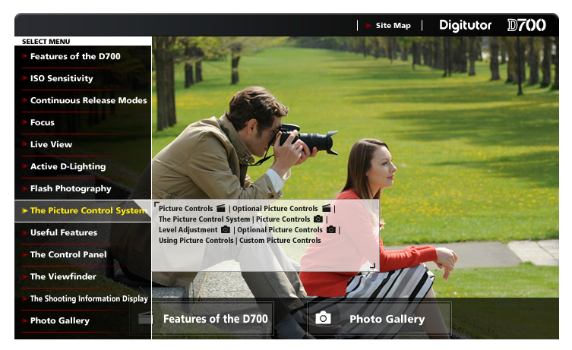
The tutorial is broken into sections. The photographer opens the tutorial and accesses the Using Picture controls tutorial (see figure 1). The left hand side of the screen consists of a viewing area for a moving video that is complete with a voice over narration and real time video showing the step by step process as it is being narrated. An instrumental soundtrack accompanies the narration throughout the tutorial.

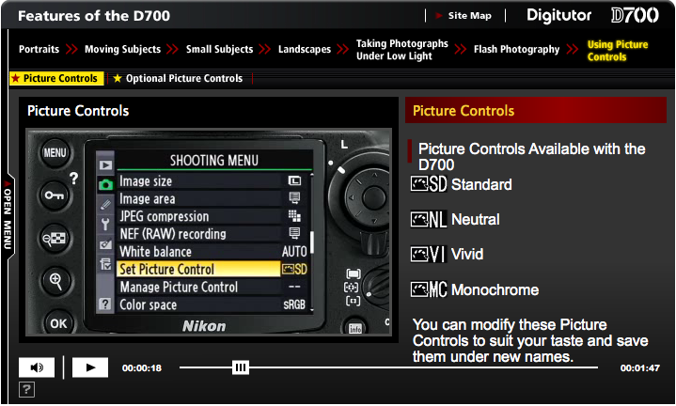

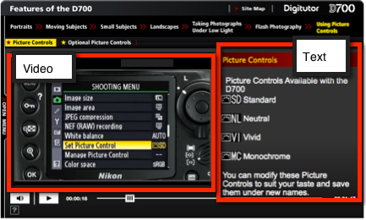

Figure 1. “Using Picture Controls” tutorial

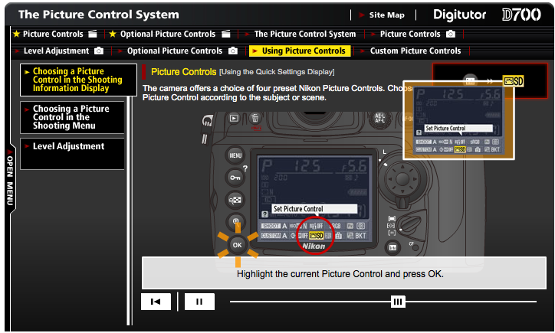
Figure 2. Multiple visual features are highlighed simultaneously which creates an overload over visual signals. This visual information coupled with a voice-over narration and instrumental music that puts an unecessary load on the user.
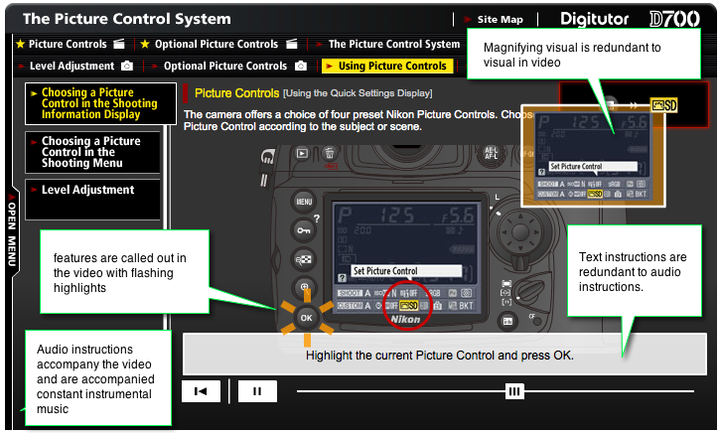
The Nikon Digitutor requires both phonological attentional resources as well as visual/spatial attentional resources. In this tutorial multiple signals are competing for the limited resources of working memory. The phonological loop is occupied by both the narration and instrumental music. Simultaneously, the visuospatial resources are being allocated to the moving images in the video, the highlighted graphics overlaid on the video (figure 2), and text box with changing contents and text. The load is heavy and exceeds the capacity of working memory. The expert photographer is cannot easily access the desired technical information. Further complicating the situation, high levels of anxiety will reduce the photographer’s attentional capacity making useful information even harder to find. Despite motivation to find important information, the demands on the attentional systems Most experts would abandon this tutorial because the effort/reward trade off is low.
In order for information to be effective, it needs to presented in a manner that is appropriate for the audience. What is effective for a novice may be ineffective for a more experienced learner (Paas, Renkl, & Sweller, 2003). While showing redundant information in a tutorial may be helpful to someone using a camera for the first time, it is not helpful for a professional photographer. Photographers who use the tutorial need to scroll through the video to find relevant information and explanations which create an additional unnecessary load. Paas, Renkl, & Sweller describe this as Extraneous or Ineffective load which interferes with the acquisition of schema and automation (2003).
Nikon.com also contains a section labeled “Learn and Explore”. This section of the site defaults to a grid of vivid thumbnail images without little accompanying text. The grid contains twelve unique visuals that are not likely to match the mental models. For example, the upper right thumbnail contains an abstract image with blue and green and vertical lines.

When mousing over the image the text, “How to capture the Wow factor” appears. Once the mouse is moved to another thumbnail, the currently displayed text disappears. Text appears and disappears over each thumbnail, as it is moused-over.
Thumbnail as viewed on page Thumbnail with mouse-over

We know that working memory capacity is limited and roughly, three to four chunks of information can be held at one time (Cowan, 2001). When mousing over multiple thumbnails at different location around the grid it will not be possible to keep track of the different choices. The photographs that serve as cover images for each topic do not have a direct relationship to the content they contained and are therefore difficult to learn. This is especially challenging since the many of the people who visit this page to explore and learn will have an extraneous load put on their working memory while using the page intended for learning. Materials that are intended for learning should support human cognitive ability by not creating unnecessary load and making necessary information easily accessible.
Conclusion
While the human perceptual and cognitive memory systems juggle limited resources in varied conditions, their capability is limited. In order to optimize human capability for processing information, the capability of the working memory needs to inform designs or products and experiences.

Bibliography
Baddeley, A. (1992). Working memory. Science, 556. Retrieved from http://www.sciencemag.org/content/255/5044/556.short

Baddeley, A. (1996). Exploring the Central Executive. The Quarterly Journal of Experimental Psychology Section A, 49(1), 5–28. doi:10.1080/713755608

Baddeley, A. (2000). The episodic buffer; a new component of working memory. Trends in cognitive sciences. Retrieved from http://www.sciencedirect.com/science/article/pii/S1364661300015382

Baddeley, A. (2003). Working memory: looking back and looking forward. Nature reviews. Neuroscience, 4(10), 829–39. doi:10.1038/nrn1201

Baddeley, Alan D., and G. J. Hitch. "Working memory." The psychology of learning and motivation 8 (1974): 47-89.

Baddeley, A. (1992). Working memory. Science, 556. Retrieved from http://www.sciencemag.org/content/255/5044/556.short
Barrouillet, P., Bernardin, S., & Camos, V. (2004). Time constraints and resource sharing in adults’ working memory spans. Journal of experimental psychology. General, 133(1), 83–100. doi:10.1037/0096-3445.133.1.83

Berti, S., Roeber, U., & Schröger, E. (2004). Bottom-Up Influences on Working Memory: Behavioral and Electrophysiological Distraction Varies with Distractor Strength. Experimental Psychology (formerly “Zeitschrift für Experimentelle Psychologie”), 51(4), 249–257. doi:10.1027/1618-3169.51.4.24

Cowan, N. (2010). Multiple Concurrent Thoughts : The Meaning and Developmental Neuropsychology of Working Memory, 35(5), 447–474. doi:10.1080/875656412010494985

Cowan, N. (2001). The magical number 4 in short-term memory: A reconsideration of mental storage capacity. Behavioral and Brain Sciences, 24, 87–114. doi:10.1017/S0140525X01003922
Engle, R. W., Tuholski, S. W., Laughlin, J. E., & Conway, a R. (1999). Working memory, short-term memory, and general fluid intelligence: a latent-variable approach. Journal of experimental psychology. General, 128(3), 309–31. Retrieved from http://www.ncbi.nlm.nih.gov/pubmed/10513398
Eysenck, M. W., Santos, R., & Calvo, M. G. (2007). Anxiety and Cognitive Performance : Attentional Control Theory, 7(2), 336–353. doi:10.1037/1528-3542.7.2.336

García-Lázaro, H. G., Ramirez-Carmona, R., Lara-Romero, R., & Roldan-Valadez, E. (2012). Neuroanatomy of episodic and semantic memory in humans: a brief review of neuroimaging studies. Neurology India, 60(6), 613–7. doi:10.4103/0028-3886.105196

Just, M. A & Carpenter, P. A. (1992). A capacity theory of comprehension: individual differences in working memory. Psychological review, 99(1), 122–49. Retrieved from http://www.ncbi.nlm.nih.gov/pubmed/1546114

Morey, C. C., & Cowan, N. (2005). When do visual and verbal memories conflict? The importance of working-memory load and retrieval. Journal of experimental psychology. Learning, memory, and cognition, 31(4), 703–13. doi:10.1037/0278-7393.31.4.703

Neisser, U. (1963). Decision-Time without Reaction-Time : Experiments in Visual Scanning. The American Journal of Psychology, 76(3), 376–385. Retrieved from http://www.jstor.org/stable/10.2307/1419778

Norman, D. A. (2004). Emotional design: Why we love (or hate) everyday things. Basic Books (AZ).

Oberauer, K. (2002). Access to information in working memory: Exploring the focus of attention. Journal of Experimental Psychology: Learning, Memory, and Cognition, 28(3), 411–421. doi:10.1037//0278-7393.28.3.411

Paas, F., Renkl, A., & Sweller, J. (2003). Cognitive Load Theory and Instructional Design: Recent Developments. Educational Psychologist, 38(1), 1–4. doi:10.1207/S15326985EP3801_1

Quinlan, P. T., & Cohen, D. J. (2012). Grouping and binding in visual short-term memory. Journal of experimental psychology. Learning, memory, and cognition, 38(5), 1432–8. doi:10.1037/a0027866

Ricker, T. J., & Cowan, N. (2010). Loss of visual working memory within seconds: the combined use of refreshable and non-refreshable features. Journal of experimental psychology. Learning, memory, and cognition, 36(6), 1355–68. doi:10.1037/a0020356

Salway, A., & Logie, R. (1995). Visuospatial working memory, movement control, and executive demands. British Journal of Psychology, 86, 253–269. Retrieved from http://onlinelibrary.wiley.com/doi/10.1111/j.2044-8295.1995.tb02560.x/abstract

Shackman, A. J., Sarinopoulos, I., Maxwell, J. S., Pizzagalli, D. A., & Davidson, R. J. (2006). Anxiety Selectively Disrupts Visuospatial Working Memory, 6(1), 40–61. doi:10.1037/1528-3542.6.1.40

